Hourly EV Charging Demand and Peak Event Prediction

Tianyu DENG
Haotian JANG
Jiahao HUANG
Junyi ZOU
Xizhu XING
Ziwen DONG

ABSTRACT
In today's society, the increasing prevalence of electric vehicles has led to a continuously growing and dynamically changing demand for power at charging stations. Therefore, understanding and predicting electric vehicle charging demand over time is very important. This paper aims to investigate whether historical electric vehicle charging data can be used to predict the charging demand for the next hour and identify potential peak charging events. The study will utilize a city-scale charging dataset and convert the raw charging records into hourly observations for analysis. For demand forecasting, a simple regression baseline will first be established, followed by the application of more advanced machine learning models to compare predictive performance. Additionally, charging demand will be transformed into binary peak event indicators based on predefined demand thresholds (for example, if the charging demand in a given hour exceeds the pre-established threshold, it will be considered a peak), allowing the investigation of peak period predictions as a classification task. Appropriate regression and classification metrics, along with visualizations such as actual versus predicted demand curves, will be employed to evaluate model performance. The project will also analyze prediction errors, potential sources of uncertainty, and limitations of the dataset and modeling approach. The expected outcome is an interpretable analysis of hourly electric vehicle charging demand and potential peak periods, which could provide data support for future research on charging station management and energy planning.
KEYWORDS
Electric Vehicle Charging; Charging Demand Forecasting; Peak Event Prediction; Regression; Classification
1 Research Questions
1.Can historical EV charging data be used to predict next-hour charging demand and identify potential peak charging events?
2.How accurately can next-hour EV charging demand be predicted?
3.Can machine learning identify potential peak charging periods?
2 Objectives
1.Clean and aggregate EV charging data into hourly observations.
2.Develop a simple baseline model for next-hour charging demand prediction.
3.Develop a classification model to identify potential peak charging events.
4.Compare model performance and analyze prediction errors.
5.Discuss the potential usefulness and limitations of the prediction results.
3 Dataset
City-scale Charging Dataset
4 Data Preprocessing
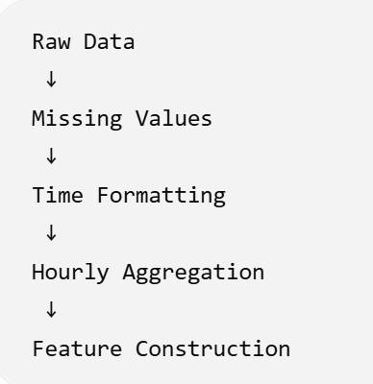
5 Demand Forecasting
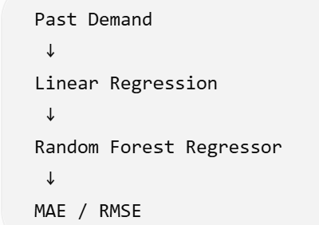
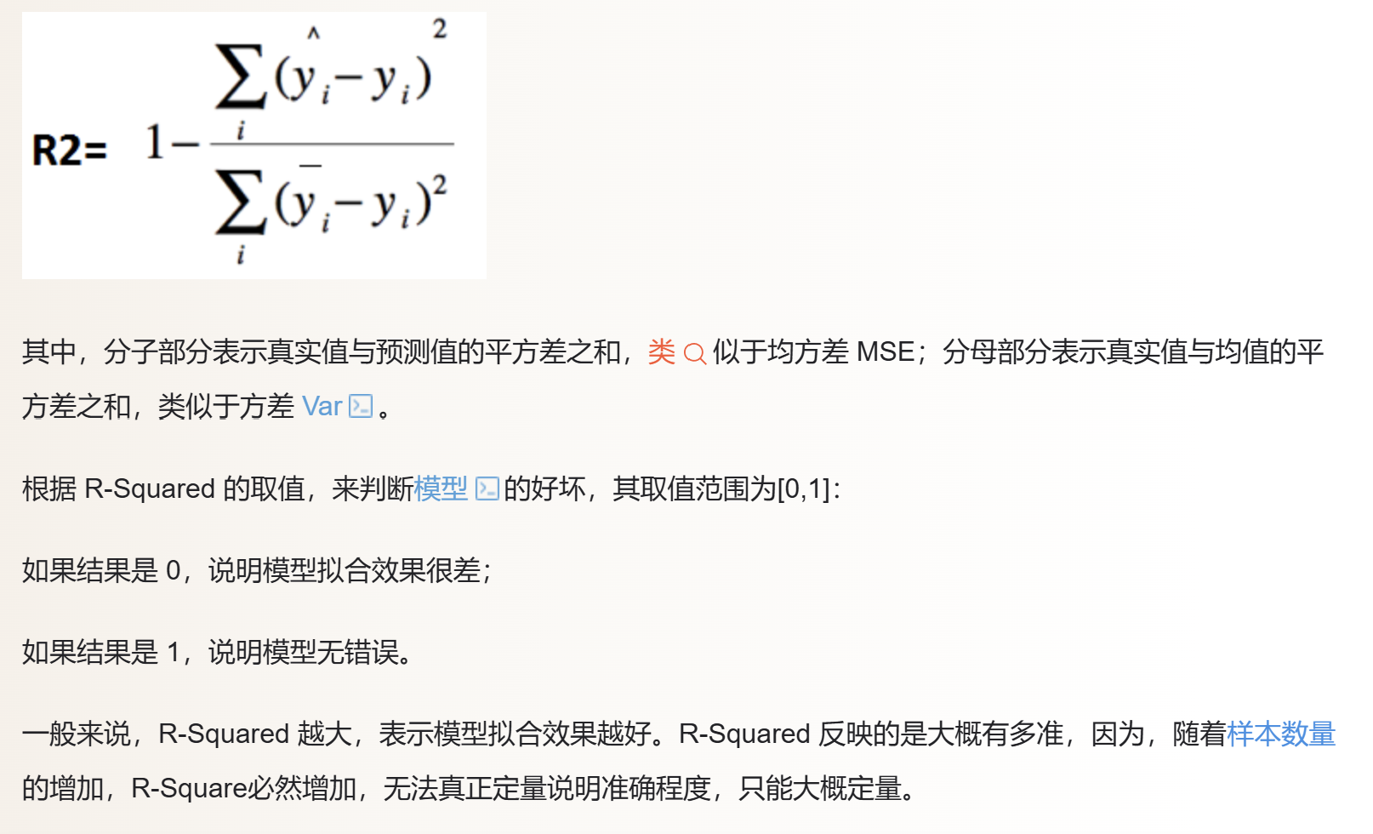
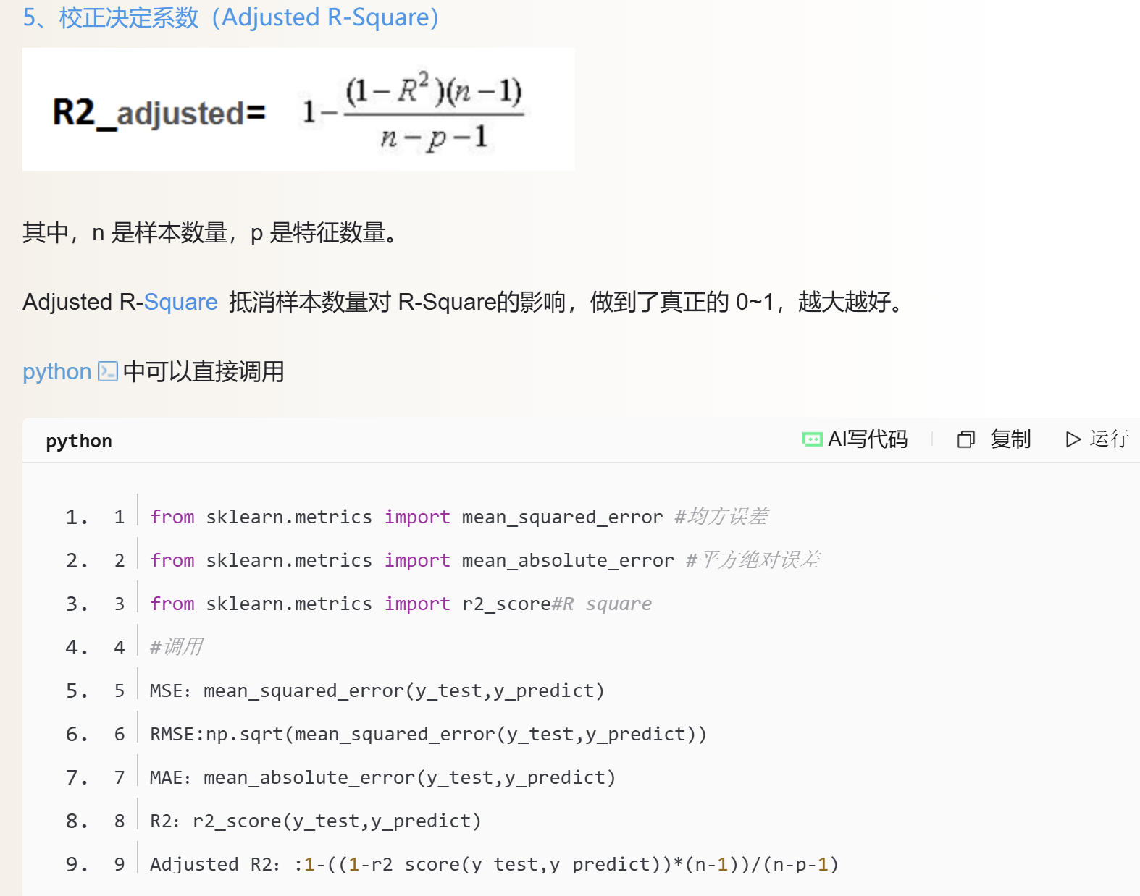
6 Peak Event Prediction
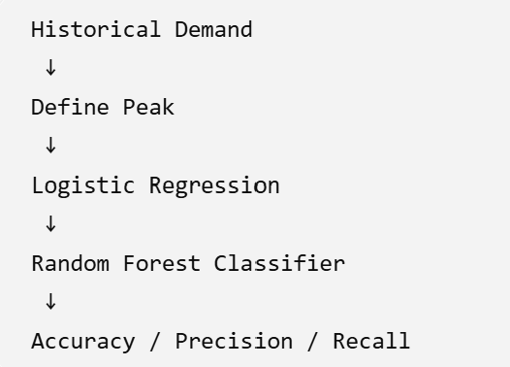
Charging demand exceeds a certain historical demand percentile
7 Visualization
time-series
hourly average
actual vs predicted
peak probability
8 Error Analysis
During which time periods does the model perform poorly in predictions?
Is it easy to overlook when a peak occurs?
9 Limitations
The dataset has limited representativeness；Peak definitions
depend on thresholds；The model can only utilize patterns present in the data；It cannot indicate causal relationships；It cannot be directly equated with a real energy dispatch system

